Intern and Training Positions Available in 2012
Property One: The Grand Hotel on Mackinac Island, Michigan
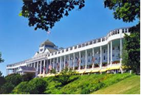www.grandhotel.com
Considered the premier property on Mackinac Island, the Grand Hotel has a rich history and is
somewhat of a celebrity (having “starred” in many films). The Grand Hotel offers service which is
quite rare in the U.S. This four star property is searching for over a large number of SIX month
placements (April 28 – October 31) in the areas of FOOD/BEVERAGE and FRONT OFFICE.
The hourly wage for non-tipped positions is $8.19. Housing is on-site and includes 3 meals daily
for $110/week.

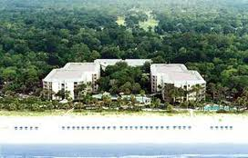Property Two: the Hilton Oceanfront Resort on Hilton Head Island, South Carolina
www.hiltonoceanfrontresort.com
This four star property is beautifully situated and well-appointed to provide its vacation
guests the highest quality service. The Hilton requests several ONE YEAR placements in
FRONT OFFICE and FOOD/BEVERAGE. Hourly pay is $9/hr for non-tipped positions. Housing
is off-site and costs $90/wk, which includes transportation to/from work and free meals when
working. Arrivals needed March through June.

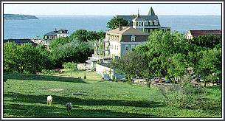Property Three: the 1661 Inn on Block Island, Rhode Island
www.blockislandresorts.com
The 1661 Inn was built in 1906 with a spectacular ocean view of the Atlantic Ocean. It has nine
spacious and elegant rooms. The Hotel Manisses, also built 1906, is a romantic Victorian hotel
featuring seventeen meticulously appointed rooms with authentic Victorian furniture. This
high-end property would like to host one placement at the FRONT DESK from April 1 through
October 31. Pay is $9.50/hr. Housing costs $75/week.

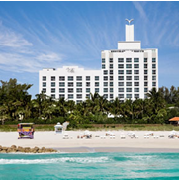Property Four: the Palms Hotel and Spa on South Beach in Miami Beach, Florida
www.thepalmshotel.com
The Palms is an oceanfront four-star resort with 251 guest rooms in 12- and 9-story towers overlooking
the sparkling Atlantic Ocean. The Palms would like to host several Front Office and Food/Beverage
placements arriving in the first half of 2012. Pay for Front Office is $10/hr. Pay for Food/Beverage is
$4.23/hr (Wait staff) and $5.45 (bar staff) plus tips for both positions. Meals are free when working.
Housing to be secured independently with DGE assistance, cost averaging $400/mth shared.

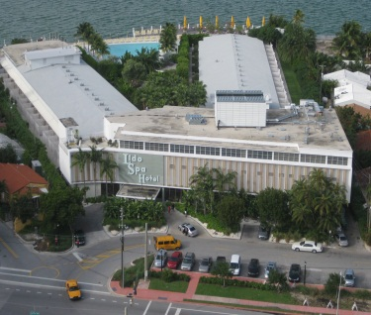Property Five: the Standard Hotel and Spa in South Beach – Miami Beach, Florida
www.standardhotels.com/miami/
The Standard sits on Biscayne Bay in South Beach with 101 rooms. Known for its chic and trendy
personality, the Standard caters to a sophisticated clientele. The Standard is offering 4 full year Food
and Beverage internships rotating through the front of house (server ($6.15/hr + tips), support
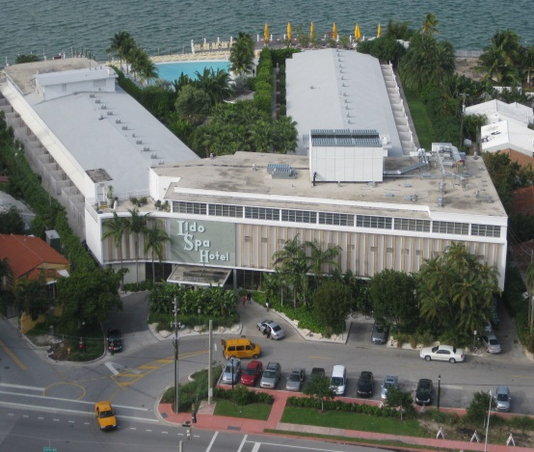staff ($6.15/hour + moderate tips), and host ($12/hour)). Also being offered is 2 full year Front Office
placements ($11/hour)rotating through Front Desk, Concierge, Reservations, and PBX. Housing to be
secured independently with DGE assistance, cost averaging $400/mth shared.

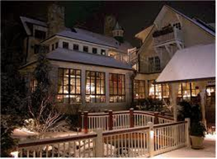
Property Six: Wolfgang’s Restaurant and Wine Bistro in Highlands, North Carolina
www.wolfgangs.net
Wolfgang’s offers a fine dining experience in the lovely community of Highlands. The
Restaurant has been awarded Best of Award of Excellence by Wine Spectator each year
since 2003. Wolfgang’s offers a full Dining Room menu as well as a Bistro menu. The
restaurant is offering two culinary 8-month placements at $8.50/hour with housing at
only $50/month. Meals are free when working. Arrivals needed in April.

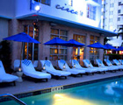Property Six: Circa 39 Hotel in South Beach, Miami Beach, Florida
www.circa39.com/
Circa 39 fuses intimate ambiance, personable service and trendy surroundings into a soothing
and playful retreat. This 100-room boutique hotel in South Beach is ideally located just steps
from the white sands and buzzing scene of South Beach. The Circa 39 is offer one full year
General Hotel internship to include rotations through all areas of the hotel (Front Desk, Food
and Beverage, Housekeeping, etc). This is an excellent opportunity to receive hands-on experience
in total hotel operations. Pay is $10/hour. Housing to be secured independently with DGE
assistance, cost averaging $400/mth shared.

Property Six: Mountain Fresh Grocery and Wine Market in Highlands, North Carolina
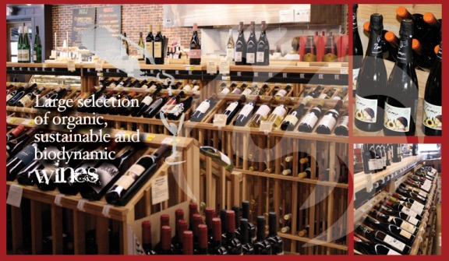www.mountainfreshgrocery.com/wine-market
Mountain Fresh, the premium grocer in this upscale community, has an inventory of more 600
wines from around the world. Their clientele depends on the market to provide wines for casual
and connoisseur wine drinkers. The wine managers have 40 years of experience in the industry
and look forward to welcoming a Intern onto their team. With Saturday wine tastings, food-
pairings, and personal service the Market is a well-respected wine source. They are also known
for their organic imported coffee which is micro-roasted on-site to Individual customer demand.
The Market is offering one full year Internship for an enthusiastic student of wine with rotations
to include sommalier, coffee roasting, and other front of house operations. Pay is $12-$15/hr.
Housing costs range between $125 and $175 per week. Excellent English, strong wine knowledge, and a big smile are required.

